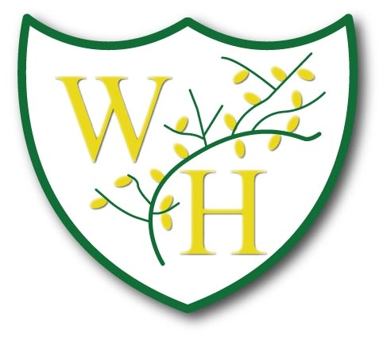
Term | Autumn 1 – ‘Settlements and Homes’
 | EYFS | Year 1 | Year 2 | Year 3 | Year 4 | Year 5 | Year 6
History or Geography Focussed Theme | All about me | Local Area- Ellesmere Port | World Explorers - Christopher Columbus  linked to World Maps - Oceans and Continents | Stone Age and Iron Age  Settlements | Ancient Greece | Anglo Saxons/ Vikings | The Industrial revolution
Enquiry Question | Who am I and where do I live? | What is in my local area? | Why do explorers decide to leave their homes? | How did homes and settlements change throughout the Stone Age? | What did the Ancient Greeks do for us? | What impact did Anglo Saxon settlement have on Britain? | What impact did the industrial revolution have on the UK and our local area?
 | Autumn 2 - ‘Inventions, Changes and Their Legacy’
 | EYFS | Year 1 | Year 2 | Year 3 | Year 4 | Year 5 | Year 6
History or Geography Focus |  | Local History- Ellesmere Port in Living Memory. | First flight and transport | Stone Age | Ancient Greece | Anglo Saxons  Vikings | The Industrial Revolution/Women and Equality
Enquiry Question | What changes do the seasons bring and which important people do we remember? | How has my local area changed? | How have past inventions impacted transport today? | What legacy did new discoveries and inventions in the Bronze and Iron Age leave on Britain? | What impact did the Ancient Greeks have on modern day life? | What was the legacy of the Viking invasion on Britain? | What legacy has been left by the invention and by changes in this period?
 | Spring 1 – ‘Big Decisions, Big Impact’
 | EYFS | Year 1 | Year 2 | Year 3 | Year 4 | Year 5 | Year 6
History or Geography Focus |  | Trees and woodlands- seasonal and daily weather patterns | Victorians – Toys in the past | Ancient Egypt | Roman Empire | Mayan Civilization | World War I and II
Enquiry Question | How do my actions affect others? | Who lives in woodlands and why? | How have Victorian toys impacted modern toys? | What was the impact of the big decisions that the Ancient Egyptians made? | Why did the Romans invade Chester? | Why are the Americas so unique? | How did the decisions made by leaders at the time lead to WW1 and WW2?
 | Spring 2 – ‘Leaders Make a Difference’
 | EYFS | Year 1 | Year 2 | Year 3 | Year 4 | Year 5 | Year 6
History or Geography Focus |  | Castles and Knights | Victorians | Ancient Egypt | Roman Empire | Mayan Civilisation | World War II and the Holocaust
Enquiry Question | Who makes the rules and why should we follow them? | What was it like to live in a castle and who is in charge? | What type of a leader was Queen Victoria? | What makes Tutankhamun one of the most famous Ancient Egyptian Pharaoh? | Who were the significant emperors during the Roman era? | Who were the Mayans and what can we learn from their leadership? | What impact was seen by the people of Europe from the decisions made by leaders?
 | Summer 1 – ‘One World’
 | EYFS | Year 1 | Year 2 | Year 3 | Year 4 | Year 5 | Year 6
History or Geography Focus |  | Seaside Holidays in the past and present  linked to Seaside Holidays - UK as an island and surrounding countries | George Mottishead & Chester Zoo | Mountains | Natural Disasters | Climate Zones and Climate Change | Rainforests
Enquiry Question | Who and what do we share our wonderful world with? | Why are coasts important?  Do coasts differ around the world? | What is George Mottershead's lasting legacy? | Why are mountains an important part of our world? | What impact do natural disasters have on our world? | How can we reduce climate change to save our future? | How did we all evolve from apes and what do we all have in common? (Global citizenship, early humans, Africa, first men)
 | Summer 2 - ‘Our Future, in Our Hands’
 | EYFS | Year 1 | Year 2 | Year 3 | Year 4 | Year 5 | Year 6
History or Geography Focus |  | Seaside – coasts Hot and cold locations | Animal conservation in non-European country. | Rivers | Caring for our planet and ensuring its future. | Human Consumerism- Sustainability | Evolution and Inheritance- protecting the future planet
Enquiry Question | How is my world changing? | How have seaside holidays changed over time?  Why do we need to protect the seaside? | Is animal conservation important? | Why is it important to look after our rivers and environment? | How can we care for our planet and ensure its future? | What is the impact of human consumerism on endangered species? | How can people around the world protect the future of the planet?

