
Head Teacher Mrs. R Jewitt  B.A. (Hons) QTS/NPQH |  | ‘Excellence in a Caring Community’  www.whitbyheath.cheshire.sch.uk  admin@whitbyheath.cheshire.sch.uk

14thJune 2022

Dear Parents/Carers
Early Years are going to be hosting a teddy bears picnic on Tuesday 19th July from 10:30am-12:30am on the large school field across the road. We will play some games before enjoying a giant picnic! We decided it would be lovely if parents and carers could join us for this experience, therefore each child can invite up to 2 grownups along to play with us, joining us on the sports day field at 10:30am! Each child will also need to bring a teddy bear and a blanket. They can bring a packed lunch picnic, or order a school packed lunch.
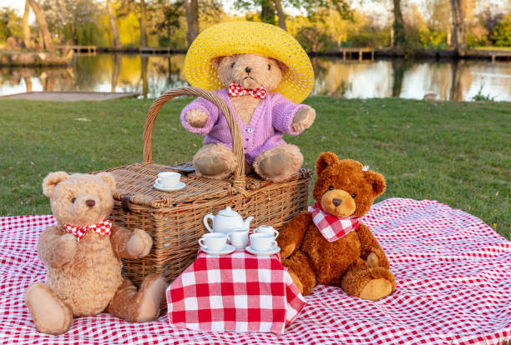
We hope to see you there!
EYFS Team
-----------------------------------------------------------------------------------------------------------------------------------------------My child______________________________will be bringing _________________ people to the teddy bears picnic. Please indicate whether your child requires a school lunch and if so which sandwich filing they would like. Return this slip to school by Thursday 30th June 2022.
Home packed lunch ▢
School packed lunch ham ▢
School packed lunch cheese ▢
School packed lunch tuna▢

