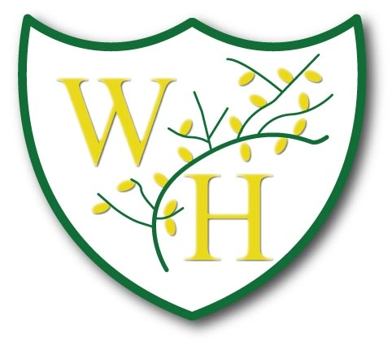
Year 3 Long Term Curriculum Plan 2022/2023

Year 3 | Autumn | Spring | Summer
 | Stone Age and Iron Age  Early Settlements and Farming  Cave paintings  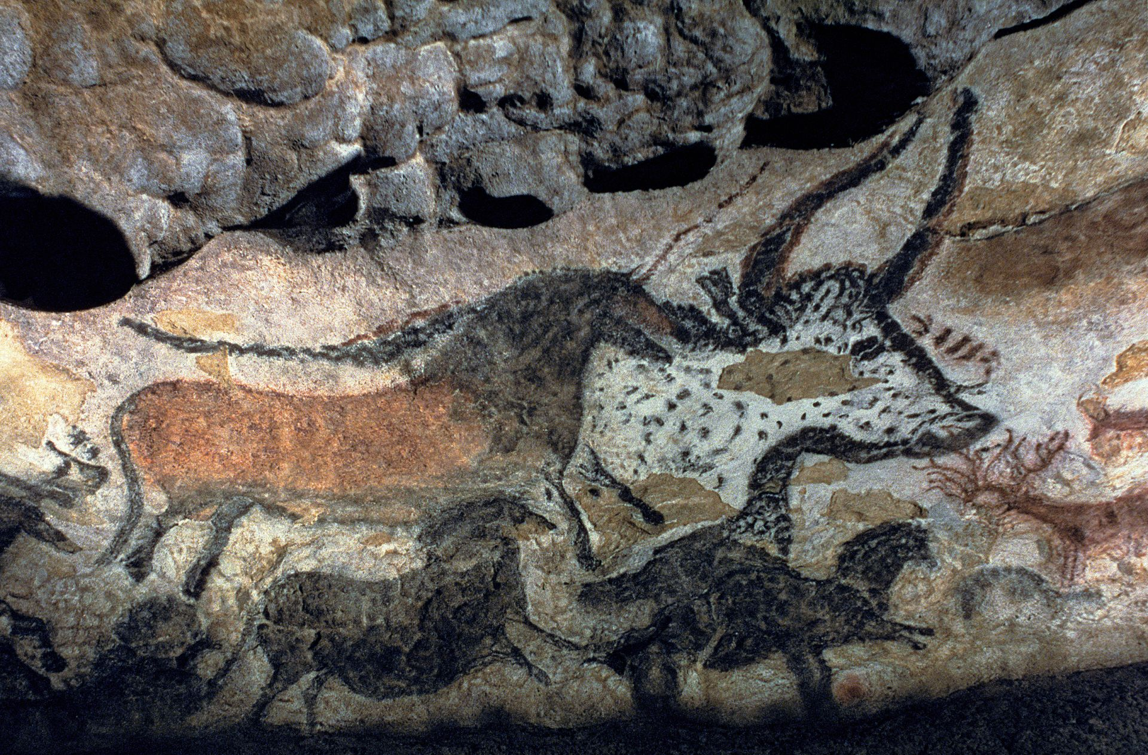 | Ancient Civilisations  Comparison of Ancient Sumer, Indus Valley, Shang Dynasty, Ancient Egypt (location, dates, inventions etc).  Tutankhamun and Howard Carter  River Nile-map skills | Mountains and Rivers  Geographical regions  Physical and Human Characteristics  Features of a river  Comparison of Snowdonia to the Alps
History | Stone age to Iron Age  Autumn 1 “Settlements and Homes”. How did homes and settlements changes throughout the Stone Age?  Autumn 2 “Inventions, Changes and their Legacy”. What legacy did new discoveries and inventions in the Bronze and Iron Age leave on Britain?  Autumn 1 and 2 vocabulary:  Britain  Palaeolithic  Neolithic  Mesolithic  Early farming  Hunter-Gatherers  Skara Brae  Stonehedge  Iron Age hill fort  Tribal kingdom  BC/AD  Prehistoric  Ancient  Archaeology  British Values Link- Mutual respect – close community links  Embracing & Understanding the of Cultures and Faiths of others – historical themes | Ancient Egypt  Spring 1 “Big decisions, Big impact”. What was the impact of the interesting decisions that the Ancient Egyptians made?  Spring 2 “Leaders make a difference”. What makes Tutankhamun one of the most famous Ancient Egyptian leaders?  Spring 1 and Spring 2 vocabulary:  Civilisation  Ancient Egypt  Nile  Pyramids  Mummification  Tombs  Tutankhamun  Pharaohs  Valley of the Kings  Cairo/Giza  AD/BC  Evidence  Hieroglyphics  Chronology  Ancient China  Shang Dynasty  British Values Link -Embracing & Understanding the of Cultures and Faiths of others – historical themes  Rule of law – citizenship and rules / laws in ancient Egypt | N/A
Geography | Early settlements and farming  Inc. Ordanance survey maps  Autumn 1/2 vocabulary:  Country Trade Landscape Hills Rural Change | N/A | Regions of the UK, physical and human characteristics, mountains around the world. Features of a river, water cycle.  Summer 1 “One world”. Why are mountains an important part of our world?  Summer 2 “Our future in our hands”. Why is it important to look after our rivers and environment?  Summer 1 and 2 Vocabulary:  Mountains  Hills, Mountain, Landscape, Rural, Pennines, Grampians, Cambrians, Snowdonia  Rivers  Landscape, Environmental, Land use,  Change/effect, Tributary, Confluence, Meander, Estuary, Source, Mouth, Precipitation
English | Autumn 1  After the Fall by Dan Santat x4 weeks  Stone Age Boy by Satoshi Kitamura (first 4 weeks in Aut 1, cont in Aut2)  Iron Man by Ted Hughes  Writing Outcome: Historical Narrative of being in the Stone Age from Modern day child’s point of view. | Spring 1  Poetry Unit- Dance with me Autumn x 2 weeks  Zeraffa Giraffa by Dianne Hoffmeyr x5 weeks  Writing Outcome: Persuasive writing. Persuasive guide for visiting Jardin des Plantes in Paris. | Summer 1  Big Blue Whale by Nicola Davies.  This Morning I met a whale by Michael Morpurgo.  Writing Outcome: Non-chronological report/persuasive article about the protection of Blue Whales.  British Values Link- Personal responsibility and liberty – environmental responsibility and freedom
 | Autumn 2  Finish Stone Age Boy x 2 weeks  Winter’s Child by Angela McAllister  Ice Palace by Robert Swindells  Writing Outcome: fantasy story of Winter’s Child. | Spring 2  Journey by Aaron Becker  Tilly Mint Tales by Berlie Doherty.  Writing outcome: Adventure story using language from Berlie Doherty book. | Summer 2  Seal Surfer by Michael Foreman  The Magpie Pie Song by Laurence Anholt  Dancing Bear by Michael Morpurgo  Writing Outcome: letter writing/recount from boy to grandfather.
Applied theme writing outcome (geography/history) | Autumn 1: Historical narrative. A day in the life of a stone age person who lived at Skara Brae (hunter/fisherman, mother, child)  Autumn 2: Fantasy story. Iron age setting-magical object | Spring 1: Informal persuasive advert to visit the Ancient Civilisations.  Spring 2: adventure story of a child exploring an Egyptian pyramid/tomb | Summer 1: non-chronological report/persuasive article about visiting Snowdonia  Summer 2: letter writing to local MP to protect rivers from pollution. Look at David Attenborough.
Science | Autumn 1: Animal Including Humans (skeletons and muscles)  Vocabulary:  skeleton, bones, muscles, support, protect, move, skull, ribs, spine, exoskeleton, endoskeleton, hydrostatic skeleton, muscles, joints, contract, relax, tendon.  Autumn 2: Animals including humans (Nutrition)  Vocabulary:  Nutrition, nutrients, carbohydrates, sugars, protein, vitamins, minerals, fibre, fat, water, healthy, unhealthy, balanced diet  British Values Link- Personal responsibility and liberty – chn learn how to be responsible for their nutrition and health | Spring 1: Forces and Magnets  Vocabulary:  Force, push, pull, twist, magnetic force, magnet, strength, attract, repel, magnetic material, metal, iron, steel, poles, north pole, south pole, friction  Spring 2: Light and Shadows  Vocabulary:  Light, light source, dark, absence of light, transparent, translucent, opaque, shiny, matt, surface, reflect, mirror, sunlight, dangerous, safety, length, shape, measure, shadow | Summer 1: Rocks and Soils  Vocabulary:  Rock, stone, pebble, boulder, grain, crystals, layers, igneous, metamorphic, sedimentary, hard, soft, texture, absorb water, permeable, absorbant, appearance, suitability, fossil, marble, chalk, granite, sandstone, slate, soil, peat, sandy/chalk/clay  Summer 2: Plants  Vocabulary:  Anther, filament, sepal, stigma, style, ovary, petals, stem, leaves, light, water, warmth, air, nutrients, carbon dioxide, oxygen, photosynthesis, pollen, insect/wind pollination, transportation, seed formation, seed dispersal (wind dispersal, animal dispersal, water dispersal)
Enhanced Curriculum Opportunities inc outdoor learning. | Stone age-Iron Age trip at Tatton Park.  Stone Age visitor in Autumn 1 (pukuB) | Egyptian artefacts at Liverpool Museum  Egyptologist visit. | RE trip to church (may be in a different term)  Science trip e.g. garden centre, fossil hunting.
Computing | Autumn 1  iProgram Games & animation development  Autumn 2  iAlgorithm Sorting and splitting. How problems can be solved more easily  British Values Link:  Personal responsibility and liberty – how to talk safely online | Spring 1  iSafe Staying safe online  Spring 2  iSimulate Exploring computer simulations  British Values Links:  Personal responsibility and liberty – how to talk safely online  Mutual respect – respecting others right to be safe online – online bullying  Embracing & Understanding the of Cultures and Faiths of others – how to speak kindly and accept all  Personal responsibility and liberty – development of relationships | Summer 1  iConnect Computer networking incl. using web browsers and search engines safely and effectively  Summer 2  iDo We Do Robotics  British Values Link:  Personal responsibility and liberty – how to talk safely online
PE | Autumn 1- Athletics/fundamental skills (strength-running, hopping and jumping)  use running, jumping, throwing and catching in isolation and in combination.  Develop flexibility, strength, technique, control and balance.  British Values link- Personal responsibility and liberty – promoting healthy lifestyles  Autumn 2- Hockey/fundamental skills (movement skills videos)  Develop flexibility, strength, technique, control and balance.  Use the skill of improvisation, responding to a stimulus  Change their movements according to different stimuli  Combine and link a small number of movement phrases and patterns  Work cooperatively with a partner and in a small group  Begin to see strength and areas to improve  British Values link- Embracing & Understanding the of Cultures and Faiths of others – through dance. Explore cultural themes/historical theme/festivals | Spring 1- Gymnastics/fundamental skills (flexibility- stretch and reach, bouncing)  Develop flexibility, strength, technique, control and balance.  Compare their performances with previous ones and demonstrate improvement to achieve their personal best.  British Values Link-Personal responsibility and liberty – promoting healthy lifestyles  Spring 2-Football/fundamental skills (kicking)  Use running, jumping, throwing and catching in isolation and in combination.  Play competitive games, modified where appropriate and apply basic principles for attacking and defending.  British Values Link-Mutual respect – respecting teammates and opposition. Learning to win and lose showing respect  Rule of law – play within the rules of the sport  Democracy – playing fair and making the correct choices | Summer 1-Multi-skills/fundamental skills (throwing and catching, sports day games)  Use running, jumping, throwing and catching in isolation and in combination.  Develop flexibility, strength, technique, control and balance.  Striking and fielding/ net wall tennis  Use running, jumping, throwing and catching in isolation and in combination.  Play competitive games, modified where appropriate and apply basic principles for attacking and defending  British Values Link-Personal responsibility and liberty – healthy lifestyle
RE | Autumn 1  Hinduism  How do Hindus view God and how is Diwali celebrated?  Autumn 2  Free Choice-Baha’I faith  British Values Link- Embracing & Understanding the of Cultures and Faiths of others | Spring 1  Christianity  How do Christians use the bible to help them with their lives?  Spring 2  Christianity  What do I think about Jesus and how is he portrayed in art? | Summer 1  Christianity  What is my point of view of God and why do people have faith?  Summer 2  Islam  How do Muslims worship?
EHWB | Autumn 1  What makes a family; features of family life  Autumn 2 Personal boundaries; safely responding to others; the impact of hurtful behaviour  British Values link- Personal responsibility and liberty – keeping safe and understanding what is hurtful  British Values Link- Personal responsibility and liberty – being aware of how behaviour affects others  British Values Link -Mutual respect – how to work effectively with other people and valuing their opinions. | Spring 1  The value of rules and laws; rights, freedoms and responsibilities  British Values Link- Rule of law –laws in Britain.  Democracy – how we can impact the rules and laws in the country through democracy  Personal responsibility and liberty – responsibility to abide by laws for everyone’s safety  Spring 2  Different jobs and skills; job stereotypes; setting personal goals  British Values Link-Personal responsibility and liberty – understanding responsibility in different job roles | Summer 1  Health choices and habits; what affects feelings; expressing feelings  Personal strengths and achievements; managing and reframing setbacks  British Values Link- Personal responsibility and liberty – respectful healthy lifestyles  Summer 2  Personal strengths and achievements; managing and reframing setbacks  Risks and hazards; safety in the local environment and unfamiliar places  British Values Link- Personal responsibility and liberty – keeping yourself safe by assessing risks
Art | Autumn 1  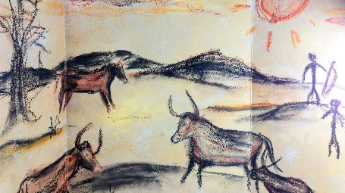  Mixed media drawings of cave paintings. Use charcoal, oils and chalks.  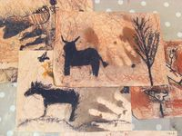  British Values Link- Rule of law - rules within artistic techniques eg cubism  Autumn 2  - Tints/shades and tones  - Leading into stone henge landscape  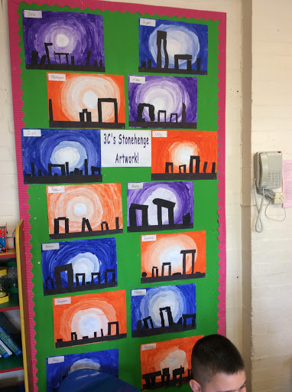  British Values Link- Personal responsibility and liberty – peer and self-assessment | Spring 1  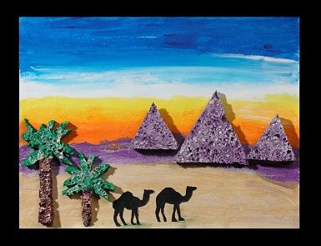  Landscape printing of an Egyptian scene (foil, carbon and mono printing).  British Values Link- Democracy – which  materials will you use?  Spring 2  Sewing-  Running, cross and back stitch.  British Values Link- Embracing & Understanding the of Cultures and Faiths of others – learning about different artists | Summer 1  Perspective drawing of black and white mountains. Use different art techniques such as shading, cross hatching and stippling to decorate.  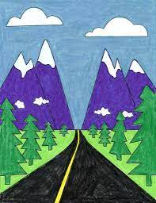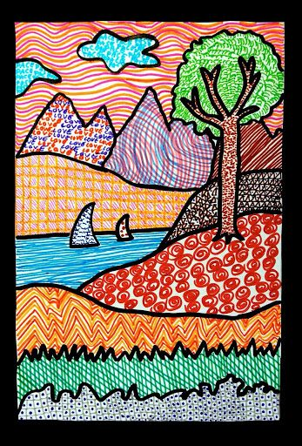  Summer 2  Patterned fish using black pens and ink.  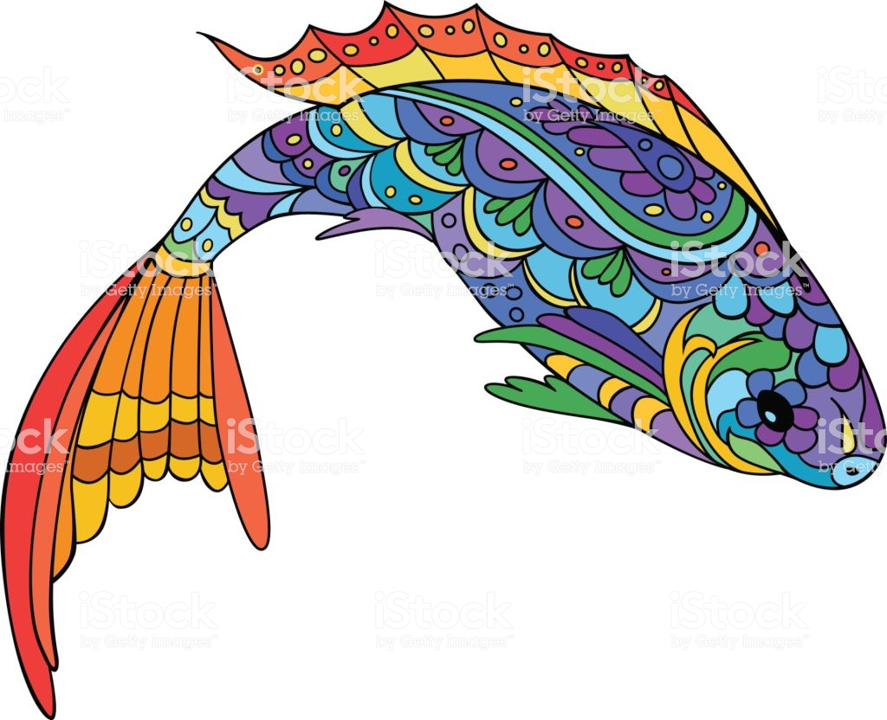  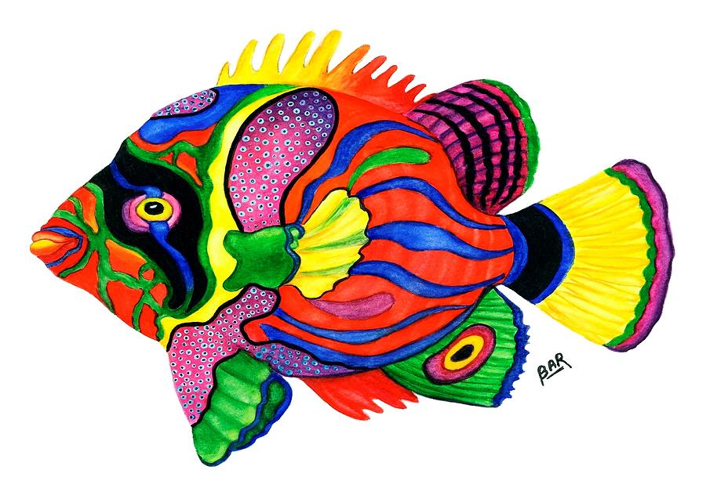  British Values Link- Mutual respect – experience and talk about artwork from different cultures and beliefs
Technology | Autumn 1  - Stone age house building using twigs/string/clay/straw and fur.  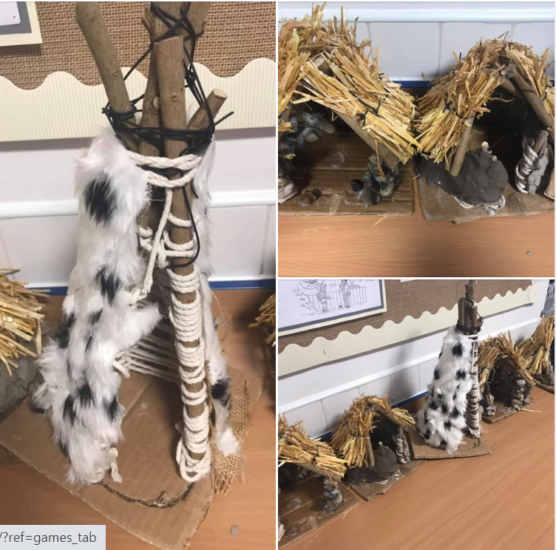  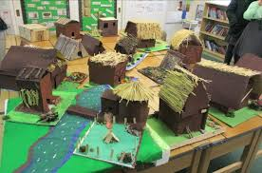  British Values Links- Personal responsibility and liberty – working collaboratively and safely with tools and electrical systems  Democracy – take turns when speaking and when working practically with others | Spring 1  Pneumatic Systems- Make an Egyptian sarcophagus.  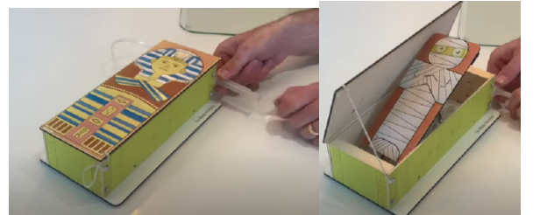  British Values Link-The rule of law – accept that when rules are not followed, there will be consequences and the reasons for these  Spring 2  - Egyptian Shadow puppets (cross-curricular link to science topic)  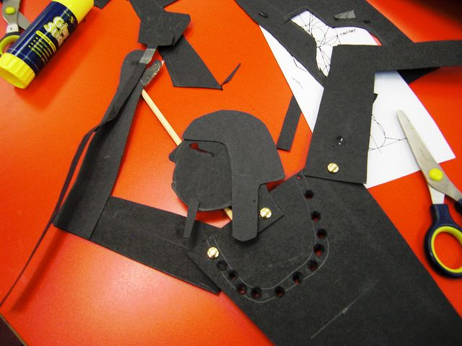  British Values Link- Personal responsibility and liberty – to listen to others’ but use their own ideas and design choices when making | Summer 1  - Electrical Systems- make a torch/lantern for a mountain ranger.  British Values Link- embracing & Understanding the of Cultures and Faiths of others – to understand that many great design ideas originate from other cultures  Summer 2  - Food technologies- make sandwiches for a picnic by the river.  British Values Link- Mutual respect – to offer supportive comments in evaluations (peer assessments) in a way in which is factual but kind
Music | Autumn 1- Let Your Spirit Fly Step 1 (R&B)  Understanding rhythm and beats  Lesson 1  - Listen and appraise- listen to the song and answer questions  - Warm up games- clapping  - Flexible games track- moving body to the beat.  Lesson 2  Musical instruments (voices)  - Warm up voices-Warm up bodies and faces, speech to singing.  - Practice the song.  Lesson 3  - Warm up voices- developing tone and range  - Practice the song  - Perform the song.  Autumn 2- Glockenspiel stage 1  Lesson 1-Step 1  - Easy E Theory videos  - Easy E- practice player 2 only with just note names then notes and note name.  - Easy E- player 1 with just note names then notes and note name  - Easy E– duet. Split class into 2 groups.  - Strictly D  - Copy Back  Lesson 2-Step 2  - Play your music theory  - Learn to Play ‘Play your music’  - Drive theory  - Learn to play ‘Drive’  Lesson 3-Step 3  Deecee’s blues  - theory video  - learn to play  - listen to improvisation  - Improvise  - Perform and improvise.  British Values Link- Mutual respect – listen and respect others when they are performing – show respect and praise strengths  Democracy – when creating music in a group, take turns and work together to make decisions | Spring 1- Three Little Birds by Bob Marley (Reggae)  Lesson 1-Step 1  - Listen and appraise- listen to the song and answer questions  - Warm up games- clapping and singing  - Flexible games track- moving body to the beat.  - Learn to sing the chorus of Three Little Birds.  Lesson 2-Step 2  - Recap the chorus  - Learn to sing the Verse  - Play your instruments-glockenspiel  Lesson 3-Step 3  - Play your instruments- glockenspiel  - Perform the song Three little birds.  Spring 2- The Dragon Song  Lesson 1-Step 1  - Listen and appraise The Dragon Song  - Warm up games- following leaders clapping rhythms, glockenspiel G and A and singing.  - Learn to sing verse 1 and the chorus of The Dragon Song.  Lesson 2-Step 2  - Listen and Appraise bird song.  - Flexible games warm up  - Play your instruments-glockenspiel  - Learn to sing the Verses  Lesson 3-Step 3  - Learn to sing the verses.  - Play your instruments- glockenspiel  - Perform the song The Dragon Song.  British Values Link- Embracing & Understanding the of Cultures and Faiths of others – link to history of music and musicians  Rule of law – behaviour link: listen carefully | Summer 1- Bringing Us Together (Disco)  Lesson 1-Step 1  - Listen and appraise Bringing Us Together  - Warm up games- (silver) following teachers clapping rhythms, glockenspiel G and A and singing.  - Learn to sing verse 1, bridge and the chorus of Bringing Us Together.  Lesson 2-Step 2  - Listen and Appraise Good Times.  - Play your instruments-glockenspiel Easy  - Learn to sing the Verses 2 and 3 and recap chorus.  Lesson 3-Step 6  - Listen and Appraise Car Wash  - Practise singing Bringing Us together  - Play your instruments- glockenspiel Medium  - Perform the song Bringing Us Together (one group singing, other group glockenspiel)  Summer 2- Reflect, Rewind and Replay (classical and revision)  Lesson 1-Step 1  - Listen and appraise L’homme Arme by Robert Morton  - Listen out- Ain’t no mountain high enough. Choose correct instruments.  - Listen and Appraise- Clash and Bang.  - Rhythm grid notation. Practice rhythms to different styles of music.  Lesson 2-Step 2  - Listen and Appraise Les Tricoteuses (The Knitters) by Francois Couperin.  - Listen Out- Small People.  - Listen and appraise- Baiskeli. Watch about the author video.  - Perform children’s favourite song this year.  Lesson 3-Step 3  - Listen and Appraise The Clock 2 Andante by Franz Joseph Haydn  - Listen Out- Vaishnava Jana  - About the Composter Video- Gwyneth Herbert.  - Finding out about Pitch video.  - Perform children’s favourite song this year.
KS2 French | Autumn 1: Introduction to French  - I can understand and follow the classroom instructions;  - Regardez, ecoutez, repetez (incorporate into every lesson).  - I can recognise the vowels in French  - I can introduce myself using greetings (hello, goodbye, my name is).  - I can say how I am.  - I can ask questions to have a simple conversation.  British Values Link- Mutual respect – communication with others increasing relatability to other cultures  Autumn 2  - I can learn about Christmas celebrations in France.  British Values Link- Embracing & Understanding the of Cultures and Faiths of others – Christmas differences | Spring 1: Numbers  - I can recognise numbers from 1-10.  - I can say how old I am.  - I can recognise numbers 11-20  Spring 2: Food  - I can recognise basic lunchtime food (bread, ham, chicken, cheese, chocolate, orange juice).  - I can create a simple café menu.  - I can recognise and recall the days of the week  British Values Link- Personal responsibility and liberty – healthy lifestyles | Summer 1: My Family  - I can name common colours (red, blue, yellow, green, white, black).  - I can identify family members (mum, dad, brother, sister).  Summer 2: Pets  - I am able to recall the names of the 4 most common pets (dog, cat, rabbit, fish).  - I can discuss and use the plural word when needed.

